**Module 2:- Hardware**

1. **Which of the following precautions should be taken before working on computer hardware?**  
   **b)** Wear an anti-static wrist strap to prevent damage from electrostatic discharge.
2. **What is the purpose of thermal paste during CPU installation?**  
   **c)** To improve thermal conductivity between the CPU and the heat sink.
3. **Which tool is used to measure the output voltage of a power supply unit (PSU)?**  
   **a)** Multimeter
4. **Which component is responsible for storing BIOS settings, such as date and time, even when the computer is powered off?**  
   **a)** CMOS battery
5. **True or False: When installing a new hard drive, it is essential to format it before use.**  
   **True**
6. **True or False: A POST (Power-On Self-Test) error indicates a problem with the CPU.**  
   **False** (A POST error can indicate various hardware issues, not just the CPU.)
7. **True or False: It is safe to remove a USB flash drive from a computer without ejecting it first.**  
   **False** (Ejecting the drive ensures all data is written and prevents corruption.)
8. **Steps to install a new graphics card in a desktop computer:**
   * Power down the computer and unplug it.
   * Open the case and locate the PCI-E slot.
   * Remove any existing GPU or slot cover.
   * Insert the new graphics card securely into the PCI-E slot.
   * Secure it with screws or locking mechanisms.
   * Connect the required power cables.
   * Close the case, plug in the computer, and install drivers after booting up.
9. **What is RAID, and what are some common RAID configurations?**
   * **RAID (Redundant Array of Independent Disks)** is a storage technology that combines multiple drives for performance, redundancy, or both.
   * **Common configurations:**
     + **RAID 0:** Striping (faster performance, no redundancy).
     + **RAID 1:** Mirroring (data is duplicated for redundancy).
     + **RAID 5:** Striping with parity (data is distributed with fault tolerance).
     + **RAID 10:** Combination of RAID 1 and RAID 0 (mirrored striping for speed and redundancy).
10. **Steps to replace a CPU fan in a desktop computer:**
11. 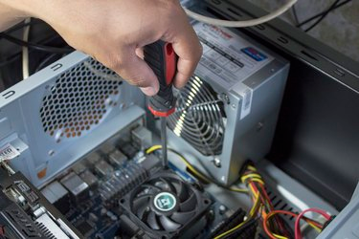

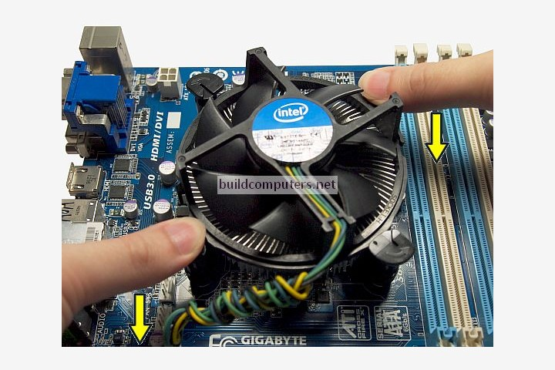

**Steps to Replace a CPU Fan in a Desktop Computer :-**

1. **Power Off and Unplug** – Shut down the computer and unplug all cables.
2. **Open the Case** – Remove the side panel for access.
3. **Locate the CPU Fan** – Find the fan attached to the CPU heat sink.
4. **Unplug the Fan Cable** – Disconnect the fan’s power cable from the motherboard.
5. **Remove the Old Fan** – Unscrew or unclip it from the heat sink.
6. **Attach the New Fan** – Secure it to the heat sink with screws or clips.
7. **Reconnect the Fan Cable** – Plug it back into the CPU fan header on the motherboard.
8. **Close the Case and Test** – Power on the computer to check if the fan is running properly.
9. **Importance of regular maintenance for computer hardware & examples:**

* **Importance:** Regular maintenance extends hardware lifespan, prevents overheating, and improves performance.
* **Examples of maintenance tasks:**
  + Cleaning dust from fans and vents.
  + Checking and replacing thermal paste.
  + Updating drivers and firmware.
  + Running disk cleanup and defragmentation.
  + Checking for hardware wear and loose connections.